# 

🔗 Website:<https://www.algouniversity.com>

### **About AlgoUniversity (YC S21)**

AlgoUniversity is *democratizing education*, by enabling personal connection between educator and student at scale. Anyone with skills can teach and anyone with will can learn and we mould them into building life transformative experiences. Currently we are **building live teaching infrastructure** that enables a handful of top educators to coach a large number of students.

We house a **young energetic team** of ACM ICPC world finalists, Olympiad medalists (won a total 4 medals for India!), people with experience of managing operations in Edtech startups, and engineers from Google, Apple, etc. Our core team is alumni from IIIT Hyderabad, IIT Bombay, IIM Indore, [check us out!](https://algouniversity.com/team/)

## **What are we looking for? 👩‍💻👨‍💻**

* We’re looking for passionate engineers, period. It doesn’t matter which parts of the stack you usually work in, as long as you’re keen to learn parts of the stack you’re less familiar with and to contribute across the board.
* We need candidates who can **get onboard ASAP** so if you have other commitments going on right now, do let us know.
* We strongly believe offline is where the real magic happens, currently we are only hiring candidates who can join us at our **Hyderabad HQ.**
* If you have experience with our **tech stack - Django, Golang, AWS, Docker, React, HTML, CSS** that’s a bonus.
* During this internship, we are seeking candidates who can become **permanent members of the team**. Therefore, we expect you to demonstrate the same level of commitment as a full-time employee. Based on your performance, we would be pleased to consider you for a full-time position.

## **Why Join?**

* You’ll have complete ownership of your work **from idea inception to design, planning and implementation**.
* There are multiple products each in different stages with lots of interesting features left to implement, so the work will always be interesting!
* Opportunity to learn about design choices and scalability while developing large scale systems which will be useful for your future endeavors.
* Work directly with the Founders of a well-funded [Y-Combinator](https://www.ycombinator.com/companies/algouniversity) incubated startup.

## **Why AlgoUniversity? 🚀**

In almost every decade, there are few ideas that seem obvious looking back. Working on them will create one hell of a story to tell. This role could be your chance to be a part of that story!

You will be working closely with the founders and have first-hand access to how they think and are scaling AlgoUniversity from the ground up! Things you build here will have a tremendous impact.

**Mentorship from a team like no other! 🔥**

You will be working with and learning from some of the coolest people in the Tech-space. Take a look at our founders, who have guided more than 500+ success stories (and counting). You will get a chance to directly work with them!

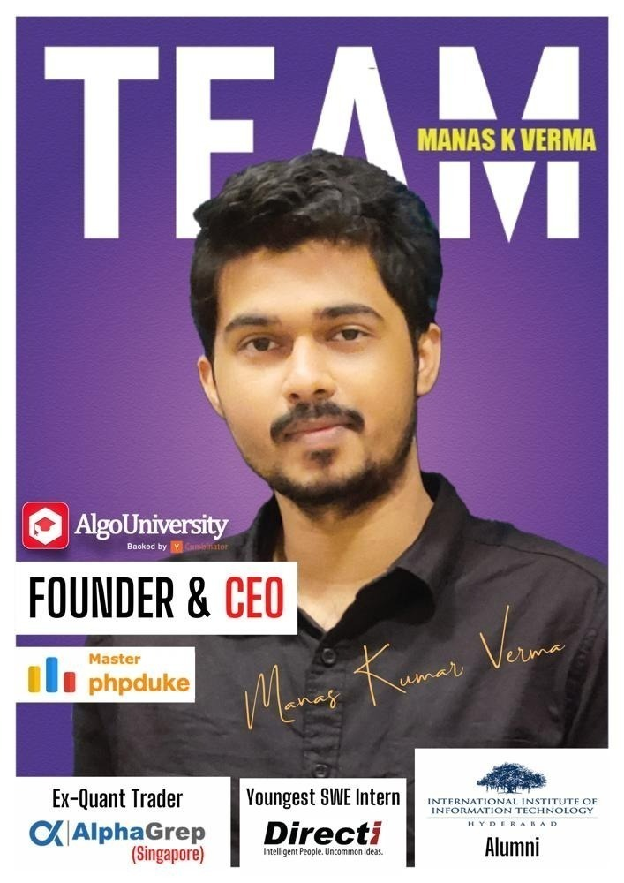

## Here’s a quick sneak-peek into Life at AlgoU! 👁️

**We work hard, but party harder 👊🎉**

We regularly go out for weekend team outings where we play futsal, bowling, indoor game-zones, foodwalks and exquisite Hyderabadi food explorations!

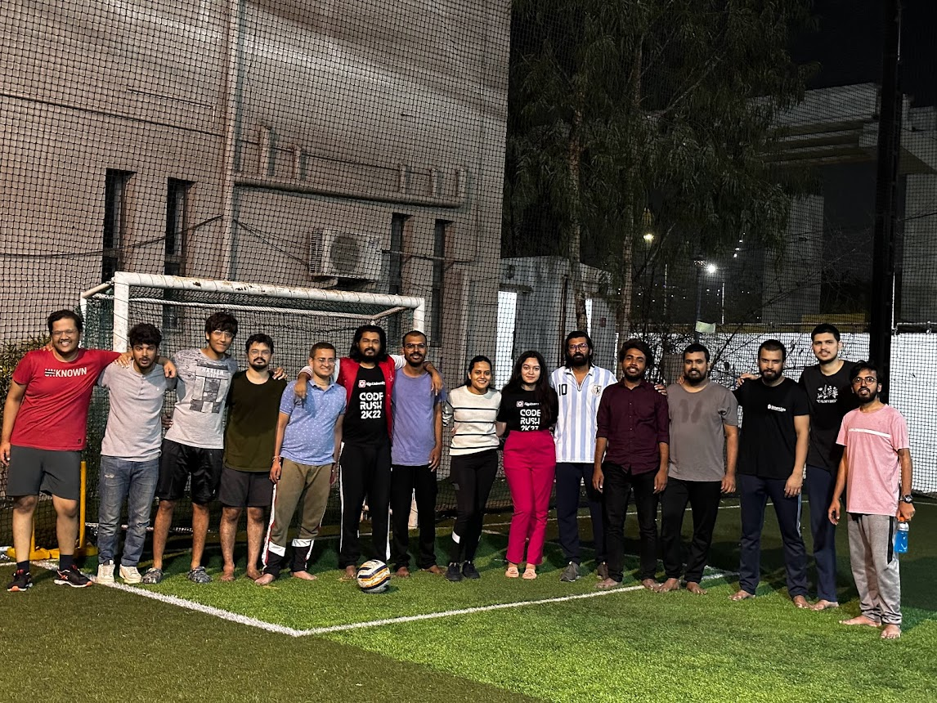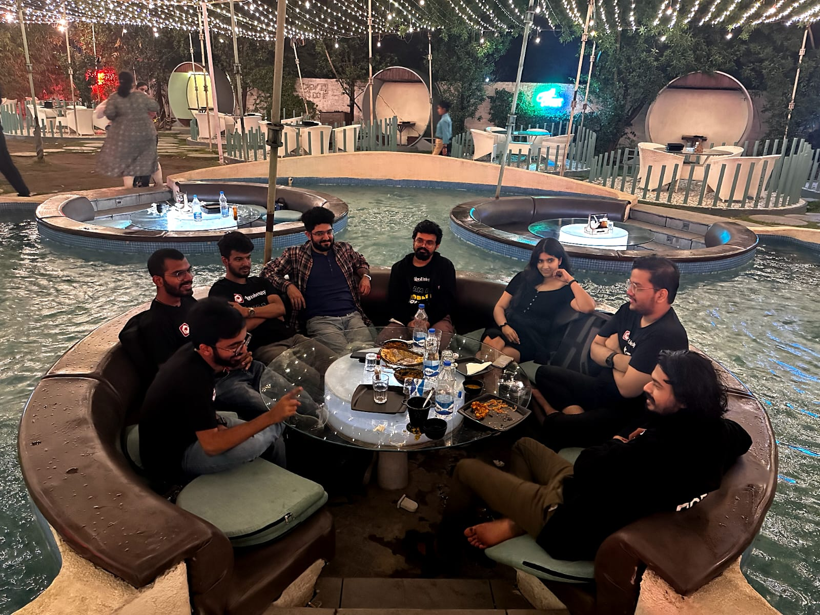

In the month of March, our team went on a work-tour across the country visiting top colleges such as IITs, NITs and IIITs, conducting our **flagship coding competition, CODERUSH**.

Checkout the teaser here 👉 [**CODE RUSH 1 MIN .mp4**](https://drive.google.com/file/d/1IGtGGgBfhCDzzwbqyUlAZe7ptPibwpEw/view?usp=sharing)